***Lab 05 – Conditional Statement***

Flow control and conditional statements are available in any programming language to alter the flow of a program.

For example, if someone wants to execute only a particular set of statements based on some certain logic, then Flow control, and conditional statements will be useful.

You will get a better understanding as we go through the various statements which are available in C#.

* [If Statement](https://www.guru99.com/c-sharp-conditional-statements.html#1)
* [Switch Statement](https://www.guru99.com/c-sharp-conditional-statements.html#2)

**1) If statement**

The if statement is used to evaluate a boolean expression before executing a set of statements. If an expression evaluates to true, then it will run one set of statements else it will run another set of statements.

**Syntax:**

if (*condition*)

{

*// block of code to be executed if the condition is True*

}

else

{

*// block of code to be executed if the condition is False*

}

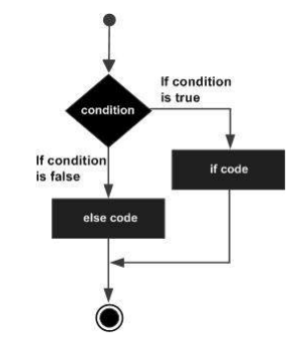**Flow Diagram**

In our example below, a comparison is made for a variable called value. If the value of the variable is less than 10, then it will run one statement, or else it will run on another statement.

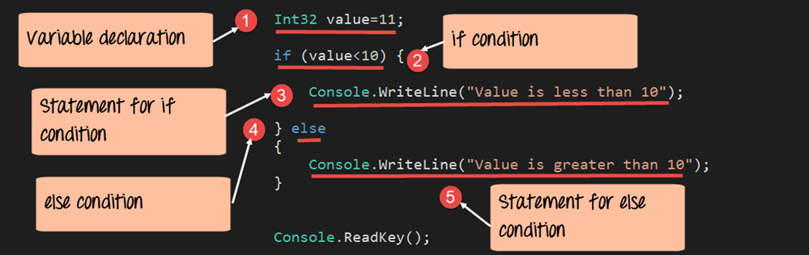

***Example 1.1***

int time = 20;

if (time < 18)

{

Console.WriteLine("Good day.");

}

else

{

Console.WriteLine("Good evening.");

}

// Outputs "Good evening."

***If-else if -else***

if (*condition1*)

{

*// block of code to be executed if condition1 is True*

}

else if (*condition2*)

{

*// block of code to be executed if the condition1 is false and condition2 is True*

}

else

{

*// block of code to be executed if the condition1 is false and condition2 is False*

}

***Example 1.2***

int time = 22;

if (time < 10)

{

Console.WriteLine("Good morning.");

}

else if (time < 20)

{

Console.WriteLine("Good day.");

}

else

{

Console.WriteLine("Good evening.");

}

// Outputs "Good evening."

## *Nested if*

## The if-else statement allows a choice to be made between two possible alternatives. Sometimes a choice must be made between more than two possibilities.

## For example the sign function in mathematics returns -1 if the argument is less than zero. Return +1 if the argument is greater than zero and returns zero if the argument is zero.

## Example

if(condition) {

}

else {

//Nested if else inside the body of “else"

if(condition2)

{

//Statements inside the body of nested "if"

}

else

{

//Statements inside the body of nested "else"

}

}

## Short Hand If...Else (Ternary Operator)

There is also a short-hand if else, which is known as the **ternary operator** because it consists of three operands. It can be used to replace multiple lines of code with a single line. It is often used to replace simple if else statements:

Syntax

variable *= (*condition*) ?* expressionTrue *:*  expressionFalse*;*

***Example 1.3***

int time = 20;

string result = (time < 18) ? "Good day.": "Good evening.";

Console.WriteLine(result);

## 2) Switch statement

The switch statement is an enhancement to the 'if' statement. If you have multiple expressions that need to be evaluated in one shot, then writing multiple 'if' statements becomes an issue.

The switch statement is used to evaluate an expression and run different statements based on the result of the expression. If one condition does not evaluate to true, the switch statement will then move to the next condition and so forth.

**Syntax:**

switch(expression)

{

case x:

// code block

break;

case y:

// code block

break;

default:

// code block

break;

}

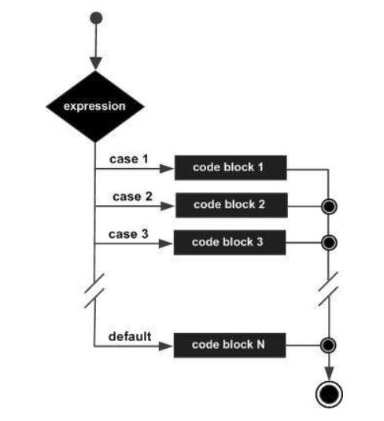**Flow Diagram**

Let's see, how this works with the below example. Here, we are again comparing the value of a variable called 'value.' We then check if the value is equal to 1, or 2, or something totally different.

[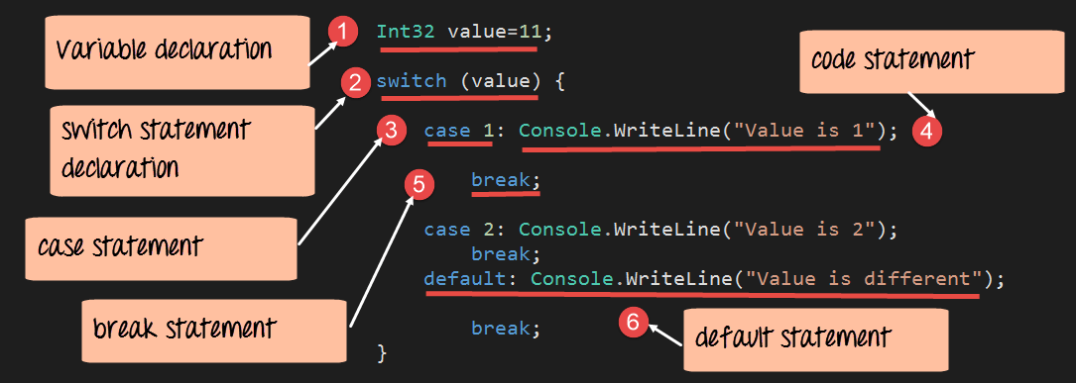](https://www.guru99.com/images/c-sharp-net/052616_1018_CFundamenta23.png)

**Example 2.1**

Char day = 4;

switch (day)

{

case 1:

Console.WriteLine("Monday");

break;

case 2:

Console.WriteLine("Tuesday");

break;

case 3:

Console.WriteLine("Wednesday");

break;

case 4:

Console.WriteLine("Thursday");

break;

case 5:

Console.WriteLine("Friday");

break;

case 6:

Console.WriteLine("Saturday");

break;

case 7:

Console.WriteLine("Sunday");

break;

}

// Outputs "Thursday" (day 4)

**Lab Tasks**

1. Create a simple program to check whether the no is even or odd.
2. Create a simple calculator using if else condition in which you will take two number as input and ask user which operation he/she wants to perform.
3. Write a Program using nested ifs in which the user is asked to do the following:
   1. Confirm if user wants to play the game “Guess the secret number”
   2. If false, then print message “Maybe next time”; if true, then ask “Enter your age”
   3. If age is less than 5 then print “You are too young to play”, else ask “Enter any number”.
   4. If number is equal to the secret number then print “You have successfully guessed the secret number; else print “You were not successful in guessing the secret number”.

**Note**: You have to store a secret number in a variable in order to compare it.

1. Create simple application which will check the vowel using switch case
2. Create a Bahria check-in system